Time Setting Question for: SD4HD, SD4HW & RSD4HD, RSD4HW

- Setting time directly:
- Log in Menu by default password: 6666
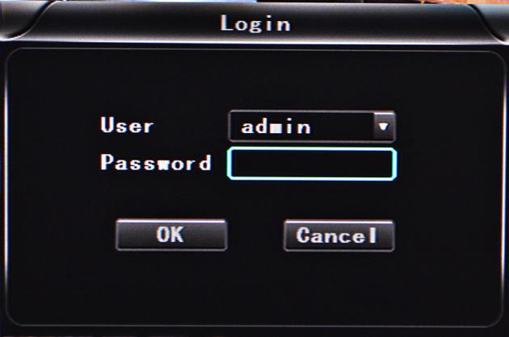

Noted: If you log in by password:1234, you just can see the setting but cannot change.

- Come into “Base” setting and check the time and click “OK” to be Blue:
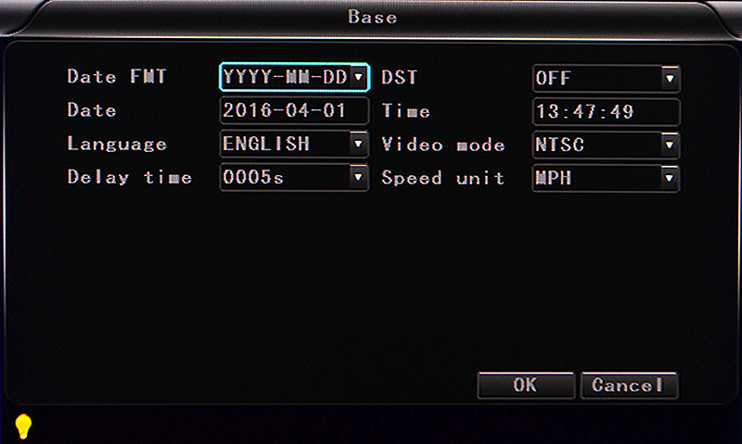

- Use delete button on remote control to delete old setting and input new time:
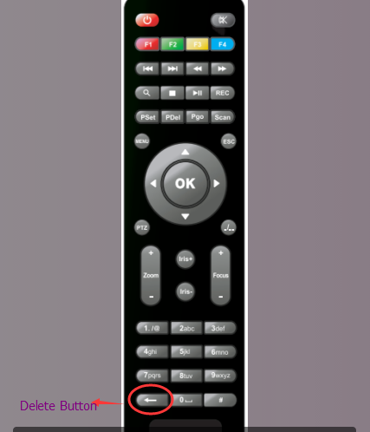

- After setting, please restart MDVRs

- GPS auto adjust time:
- GPS antenna connects with MDVR and GPS works

- Come in “GPS” setting and settle time district in the “GPS timing”. For example; UTC-5, Eastern standard time, you just need to choose UTC-5 in the GPS timing and restart MDVR, it will adjust the time automatically.
